NUTeams onboarding Portfolio prt 2
This is your NUTeams project portfolio. Download and complete this document as you complete your project and submit it as evidence the additional team tasks and project tasks have been completed.
All tasks are required, all evidence is required for each task. This document will outline some but not necessarily all tasks required by your team.
These tasks will vary considerably between teams with respect to, which tasks are required, due dates and type of evidence. Ensure you are complying with what your team requests of you. Use this document as a way of keeping track and ensuring you have evidence of tasks completed.
Most evidence will require an Approver. The Approvers for these tasks must come from your own team 2026 are:
Malcolm Sidney (any), Adam Minett (NURacing), John Wong (NUMarine), Rylie Heller (NURocketry), Ben Erwin (NUMarine), Riley Wollen (NURacing), Oliver O’Grady (NURocketry), and Dylan Cuskelly (any).
It is your responsibility to manage your time appropriately as a professional. Your ability to complete tasks on time and to an appropriate standard is one of the components being measured.
If you are having trouble completing tasks or collecting appropriate evidence reach out early.
If you are uncomfortable having your photo taken please reach out so we can organise other arrangements.
Submission requirements
You are required to name this document: Firstname_lastname_c1234567_NUTeams2200Project _Portfolio_2026.
You are required to submit this document to canvas as a .docx as ‘Assignment 2’ before the due date.

CAN bus – Deadline 25/11/2026
Your project will require you to learn Team specific skills in addition to those covered in the general onboarding. As you complete these training tasks provide evidence in this section.

Provide evidence in the form of screenshots/photos that you have completed the training.
You
Approver
Training
Figure 1 Ensure that it is apparent from your photo that you have completed the training.
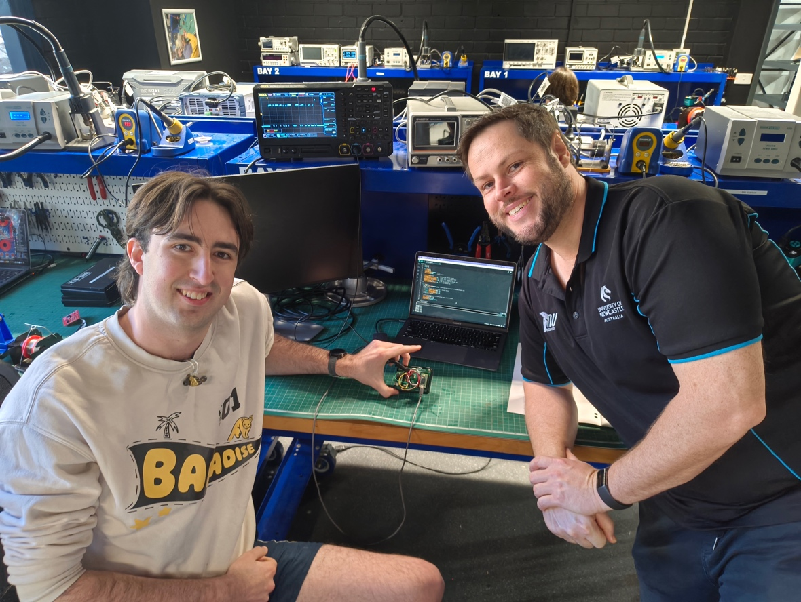

Testing day participation – Deadline 13/11/2026
Participate in a track day. This will be a whole day event that happens off campus at a testing site. It may happen on a weekend. The date and time of which will be determined by thee testing site as much as by NUTeams.
You will be required to adhere to all safety procedures for the day.
You will likely be required to complete some pretraining/briefing and complete some administrative tasks before being allowed to attend.
You may be required to have an active role in preparing for the day or on the day. However, it is as likely you will not be qualified to engage with any equipment on the day and will be limited to a passive observer.
You
Approver
Testing Day
Figure 1 Ensure that it is apparent from your photo that you were present at the testing day.

Team activity participation – Deadline 13/11/2026
You will be required to make contributions to your team throughout the semester. These will not be activities directly related to your project but activities in the services of the teams as a whole. A minimum of 10 hrs equivalent is expected. Appropriate team activities will be entirely at the discretion of your individual teams.
You
Approver
Team Activity
Figure 1 Ensure that it is apparent from your photo that you were helpful with at the team activity.

Pre-demonstration inspections (scrutineering) – Deadline 6/11/2026
Before being able to demonstrate your device you will be required to pass a Tech inspection / proof of readiness. This is required for all of our competition teams and is for you as well. You will have a base level of requirements you will need to be able to prove you can meet to be able to safely test/demonstrate your project. It MUST be satisfactorily completed before the demonstration.

You
Approver
Approved project
Figure 1 Ensure that it is apparent from your photo that you passed your pre-demonstration inspection.

Demonstration – Deadline 14/11/2026 (Saturday) TBC
Provide evidence you completed your demonstration.
You
Approver
Demonstrated project
Figure 1 Ensure that it is apparent from your photo that you completed your demonstration.

